Principal Component Analysis
Teaching Notes
A from-scratch guide to dimensionality reduction, written for someone who has never seen it before. Explains PCA with a tiny 5-point worked example done entirely by hand, then shows the same ideas at full scale on an 18-feature credit risk dataset.

Contents

1. The Problem PCA Solves: Too Many Overlapping Features
Real datasets are often wide: dozens of columns, many of which are secretly telling you the same story. A bank's credit risk file might record Annual_Income, Monthly_Income, and Disposable_Income as three separate columns, but they all move together, someone with a high annual income almost always has a high monthly income too. These columns are correlated, and correlated columns are redundant: they add columns to your dataset without adding much new information.
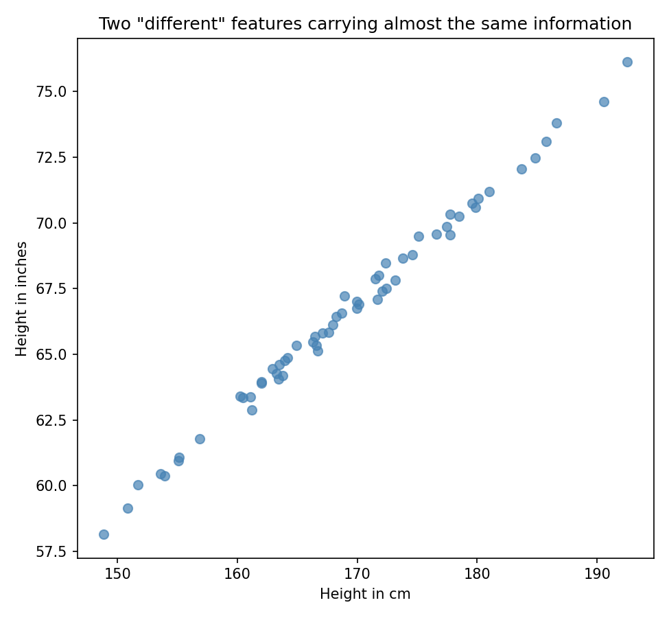
Figure 1. Height measured in centimeters vs. the same people's height in inches. Two columns, one underlying fact. A trend line through these points would explain nearly all of the spread.
Redundant features cause real problems: they slow models down, they can make some algorithms numerically unstable, and they make data hard for a person to visualize or reason about (nobody can look at an 18-dimensional scatter plot). Principal Component Analysis (PCA) is a technique for compressing a wide, redundant dataset down into a small number of new columns, called principal components, that capture as much of the original information as possible.

2. The Core Idea: Find the Directions Where the Data Spreads Out Most
Forget columns for a moment and just picture the data as a cloud of points. Some directions through that cloud show a lot of spread (the points are strung out widely along that line), and other directions show very little spread (the points barely move if you look along that line). PCA's whole idea is: find the direction of maximum spread first, call it Principal Component 1 (PC1). Then find the next direction of maximum spread that is perpendicular (uncorrelated) to PC1, call it PC2. Keep going until you've described the cloud in as many directions as it had original columns.
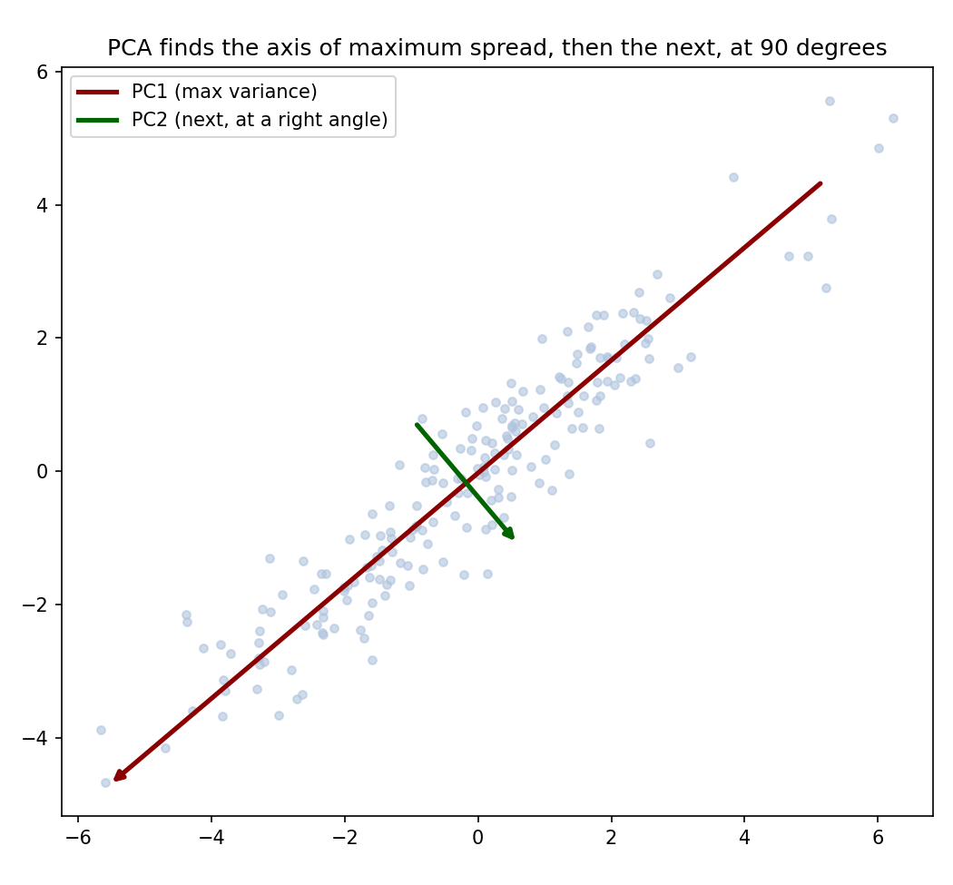
Figure 2. A cloud of correlated points. PC1 (dark red) points along the direction of greatest spread. PC2 (dark green) is perpendicular to PC1 and captures whatever spread is left over.
The payoff: spread is information. A direction where all the points pile up close together tells you almost nothing about what makes one point different from another. A direction with a lot of spread is doing a lot of the work of distinguishing your data points. By keeping only the first few principal components (the highest-spread directions) and dropping the rest, you keep most of the useful information while throwing away most of the columns.
"Spread", precisely, means variance. PCA is literally finding the directions that maximize variance, subject to each new direction being uncorrelated with (perpendicular to) every direction already chosen:
PC1 = the direction that maximizes Var(projected data)
PC2 = the direction that maximizes Var(projected data),
subject to PC2 ⊥ PC1 (uncorrelated with PC1)

3. A Tiny Worked Example, Done by Hand
The math behind PCA (eigenvectors of a covariance matrix) sounds intimidating, but on a handful of points it's just arithmetic. Take five points with two features each:
Point | Feature 1 | Feature 2
P1 | 1 | 2
P2 | 2 | 4
P3 | 3 | 5
P4 | 4 | 4
P5 | 5 | 6

Step 1 — Center the data
First find the mean of each column, then subtract it from every point, so the cloud is centered on the origin:
mean = (3.0, 4.2)
Point | Centered F1 | Centered F2
P1 | −2.0 | −2.2
P2 | −1.0 | −0.2
P3 | 0.0 | 0.8
P4 | 1.0 | −0.2
P5 | 2.0 | 1.8

Step 2 — Compute the covariance matrix
The covariance matrix summarizes how much each feature varies, and how much the two features vary together, in a compact 2×2 table (dividing by n−1 = 4):
Var(F1) = Σ(centered F1)² / 4 = 10.0 / 4 = 2.5
Var(F2) = Σ(centered F2)² / 4 = 8.8 / 4 = 2.2
Cov(F1,F2) = Σ(centered F1 × centered F2) / 4 = 8.0 / 4 = 2.0
Covariance matrix =
[ 2.5 2.0 ]
[ 2.0 2.2 ]
The fact that Cov(F1,F2) = 2.0 is nowhere near zero already tells us these two features are strongly correlated, exactly the redundancy PCA is meant to compress.

Step 3 — Find the eigenvalues and eigenvectors
This is the one genuinely linear-algebra step: the directions of maximum spread turn out to be exactly the eigenvectors of the covariance matrix, and the amount of spread along each one is its eigenvalue. Solving for this 2×2 matrix gives:
Eigenvalues: λ₁ = 4.356, λ₂ = 0.344
Eigenvector for λ₁ (PC1 direction, normalized): (0.733, 0.680)
PC1's direction, (0.733, 0.680), says: “as you move along this line, Feature 1 and Feature 2 increase together, in roughly a 0.73-to-0.68 ratio.” That's just a formal way of restating what Figure 3 shows by eye: the points trace out a rising diagonal line.

Step 4 — Compute explained variance
% variance explained by PC1 = λ₁ / (λ₁+λ₂) = 4.356 / 4.700 = 92.7%
% variance explained by PC2 = λ₂ / (λ₁+λ₂) = 0.344 / 4.700 = 7.3%
92.7% of the total spread in this little dataset lies along a single line. If we kept only PC1 and threw away PC2, we would still be describing these five points almost completely with a single number each instead of two.

Step 5 — Project the points onto PC1
To get each point's new, single-number PC1 coordinate, take the dot product of its centered position with the PC1 direction:
Point | Centered position | Projection onto PC1
P1 | (−2.0, −2.2) | −2.962
P2 | (−1.0, −0.2) | −0.869
P3 | (0.0, 0.8) | 0.544
P4 | (1.0, −0.2) | 0.597
P5 | (2.0, 1.8) | 2.690
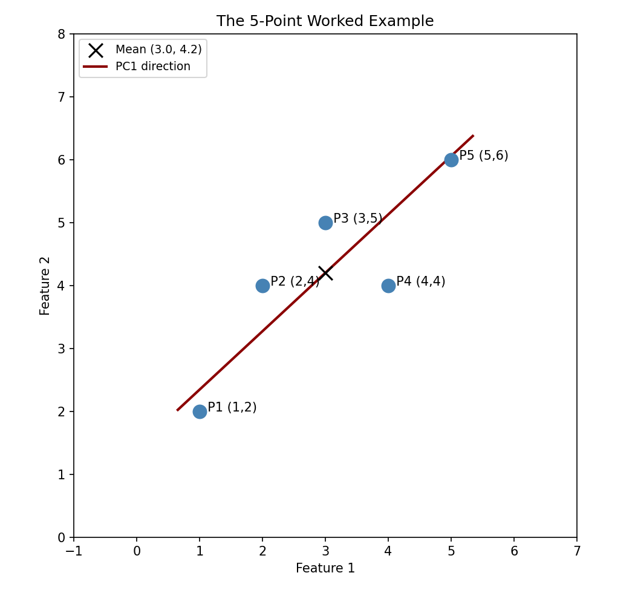
Figure 3. The five points, their mean (X), and the PC1 direction. Points below-left of the mean get a negative PC1 score, points above-right get a positive one, exactly the ordering in the table above.
Two numbers per point (Feature 1, Feature 2) have become one number per point (its PC1 score), and that one number still separates P1 (most negative) from P5 (most positive) in the same order the original two columns did. That is PCA in miniature.

4. At Full Scale: Explained Variance and the Scree Plot
The worked example had 2 original features, so there were only 2 possible components. A real dataset, an 18-feature credit risk profile (income, debt, payment history, credit utilization, account age, and more, for 3,000 customers), produces 18 principal components, one per original feature. The question becomes: how many of those 18 do we actually need to keep?
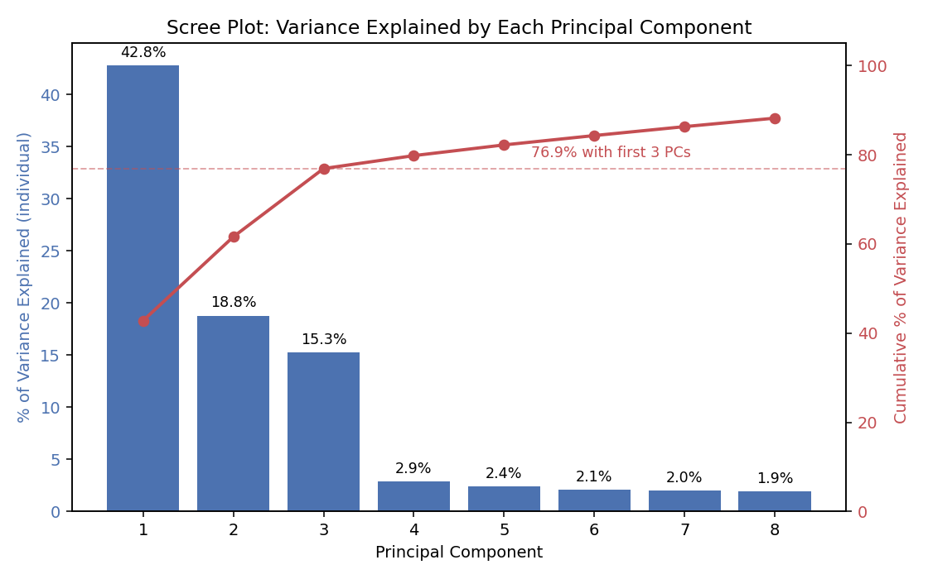
Figure 4. A scree plot: bars show how much variance each individual component explains, the line shows the running (cumulative) total. The first 3 components already capture 76.9% of the total variance in all 18 original features.
Notice the sharp “elbow” right after component 3: components 1–3 explain 42.8%, 18.8%, and 15.3% respectively, then components 4 onward each explain under 3%. That elbow is the visual signal that most of the real structure in this data lives in just 3 directions, the other 15 are mostly noise. A common rule of thumb is to keep components up to the elbow, or enough components to cross a target like 80–90% cumulative variance.

5. Reading the Loadings: What Does a Component Actually Mean?
A principal component is a weighted combination of the original features, and those weights (called loadings) are what let you translate an abstract “PC1” back into a business story. A large positive loading means that feature increases strongly as PC1 increases; a large negative loading means it decreases.
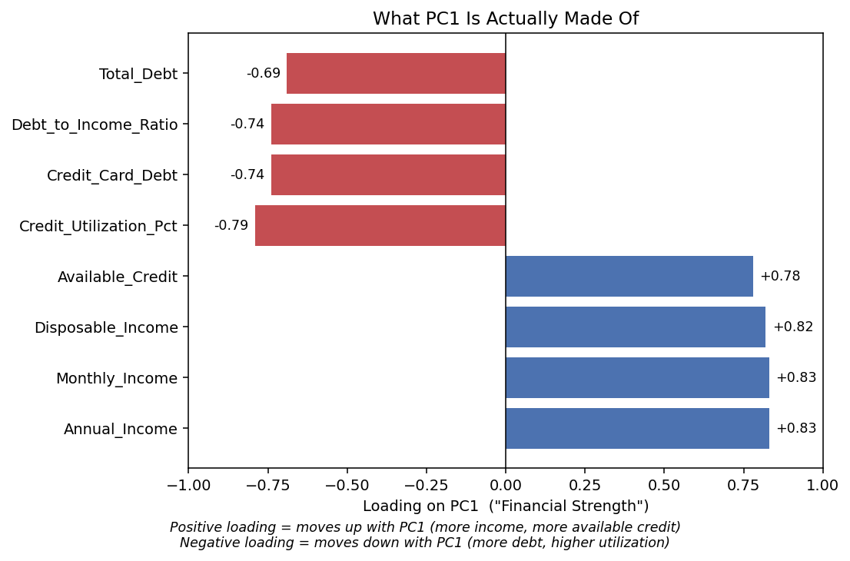
Figure 5. PC1's loadings for the credit risk data. Income and available-credit features load strongly positive; debt and utilization features load strongly negative.
Reading Figure 5: customers with a high PC1 score have high income, high disposable income, and plenty of available credit, and low debt, low credit-card balances, and low utilization. In other words, PC1 is a single number that behaves like an overall “Financial Strength” score, built automatically, without anyone telling PCA that income and debt matter, PCA discovered that these particular features move together and compressed them into one axis.
Applying the same reading to the next two components:
Component | Variance explained | Dominant features | Business meaning
PC1 | 42.8% | Income, disposable income, available credit (+) / debt, utilization (−) | Financial Strength
PC2 | 18.8% | Account age, employment tenure (+) / debt (mixed) | Credit Maturity
PC3 | 15.3% | Payment history score, on-time % (+) / late payments, days late (−) | Payment Discipline

This is the real value of PCA beyond just compression: three genuinely interpretable business concepts (how well-off, how established, how reliable a customer is) emerged directly from the correlation structure of 18 raw columns, nobody hand-engineered them.

6. Why We Standardize Before Running PCA
PCA chases variance, and variance is sensitive to the units a feature happens to be measured in. Annual_Income ranges over tens of thousands of dollars; Debt_to_Income_Ratio ranges over roughly 1–85. If you hand PCA the raw numbers, income's sheer numerical scale will dominate the variance calculation, not because income is more important, but because its numbers are simply bigger.
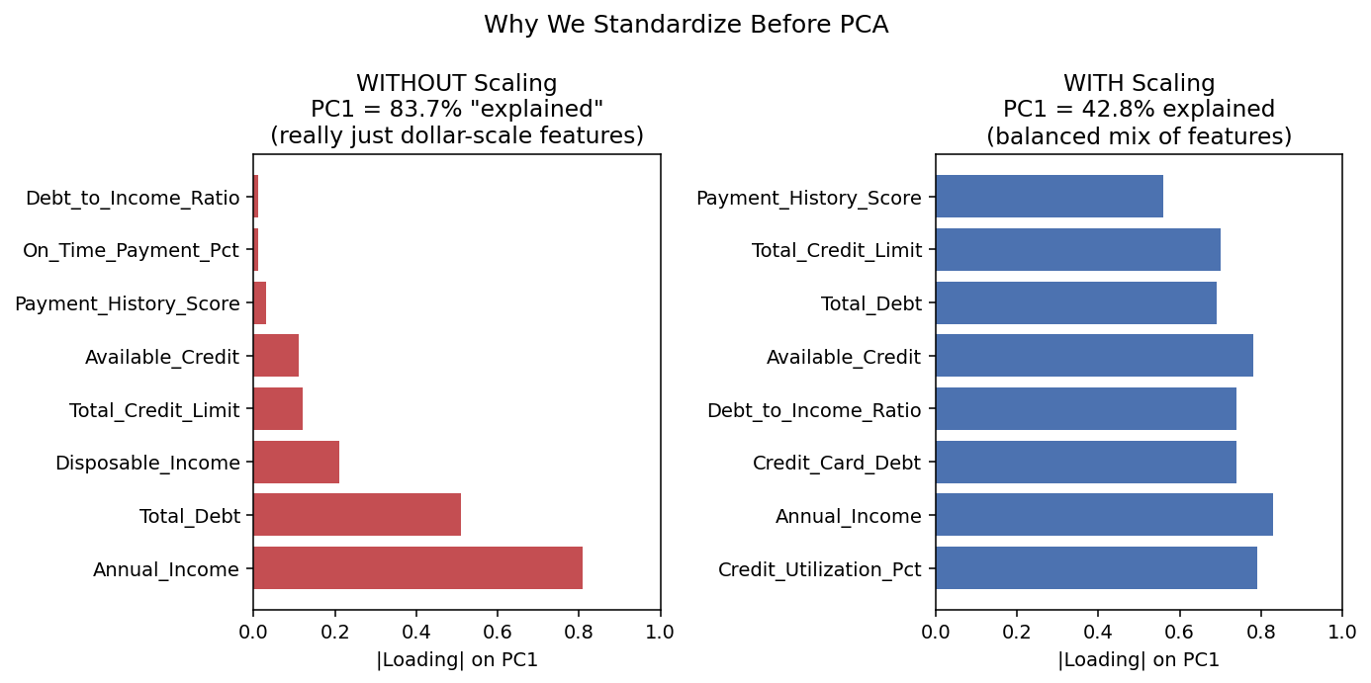
Figure 6. Left: PCA on unscaled data. PC1 is almost entirely income and debt (the two largest-scale columns) and “explains” an inflated 83.7% of variance, an artifact of units, not real structure. Right: after standardizing every feature to mean 0, standard deviation 1, PC1 draws a balanced mix from across all the features and explained variance drops to a more honest 42.8%.
The fix is standardization: rescale every feature to have mean 0 and standard deviation 1 before running PCA (scikit-learn's StandardScaler does exactly this). After scaling, a $1 difference in income and a 1-point difference in a payment score are put on the same footing, so PCA finds directions of genuine correlation instead of directions of measurement scale.
standardized value = (original value − feature mean) / feature standard deviation
- Always standardize first when features are on different units or scales (dollars, percentages, counts, years, scores).
- Standardizing is unnecessary only when every feature is already on a naturally comparable scale (for example, pixel intensities 0–255 across an image).

7. What We Give Up: Reconstruction Error
Keeping only 3 of 18 components means discarding information, PCA is a compression technique, and like any compression, something is lost. That loss can be measured directly: take the 3-component representation of a customer, project it back out to 18 dimensions, and compare it to the original 18 numbers.
Reconstruction error = average squared difference between original (standardized) values and their 3-component reconstruction
On the credit risk data, reconstructing from just 3 components gives a mean squared reconstruction error of 0.2311, on data that was standardized to variance 1 per feature. In other words, compressing 18 numbers down to 3 and back leaves an average error of roughly √0.2311 ≈ 0.48 standard deviations per feature, a real but modest cost for a 6× reduction in the number of columns. This is the fundamental trade-off of PCA: more components kept, less error, but less compression; fewer components, more compression, more error. The scree plot (Figure 4) is exactly the tool for finding a good place to stop.

8. Strengths, Weaknesses, and When to Use PCA

Strengths
- Removes redundancy: correlated features get compressed into a smaller set of uncorrelated components.
- Makes high-dimensional data visualizable, plotting the first 2–3 components is often the only practical way to “see” a wide dataset.
- Can speed up and stabilize downstream models by reducing the number of input features, especially when those features are highly correlated.
- Fully deterministic and mathematically well understood, the same data always produces the same components.

Weaknesses
- Components are linear combinations of every original feature, they are usually harder to explain to a non-technical audience than the raw columns, even when a business label like “Financial Strength” can be attached after the fact.
- Only captures linear structure. If the real relationships between features are curved, PCA will miss them (t-SNE and other nonlinear methods exist for that case).
- Sensitive to feature scaling, skipping standardization silently biases results toward large-scale features (Section 6).
- Some information is always lost once components are dropped, the only question is how much (Section 7).

Rule of thumb: reach for PCA when you have many correlated numeric features and want to compress, denoise, or visualize them, especially as a preprocessing step before clustering or modeling. Skip it when you need every result to be explainable in terms of the original columns verbatim, or when you suspect the important relationships in your data are strongly nonlinear.

9. Summary Cheat Sheet
- PCA finds new axes (principal components) that point along the directions where the data spreads out the most.
- PC1 captures the most variance, PC2 the next most while staying uncorrelated with PC1, and so on, up to one component per original feature.
- Under the hood, the components are the eigenvectors of the covariance matrix, and each component's explained variance is its eigenvalue.
- A scree plot (variance explained per component) is how you decide how many components to keep, look for the elbow.
- Loadings tell you what each component means in terms of the original features, often revealing an interpretable business concept.
- Always standardize features first unless they're already on a common scale, otherwise large-scale features dominate for the wrong reason.
- Dropping components always costs some reconstruction accuracy, PCA trades a small, measurable amount of information for a large reduction in dimensionality.

